# CS 5200 Hands-on Exercise

## **[50pt] Database Implementation**

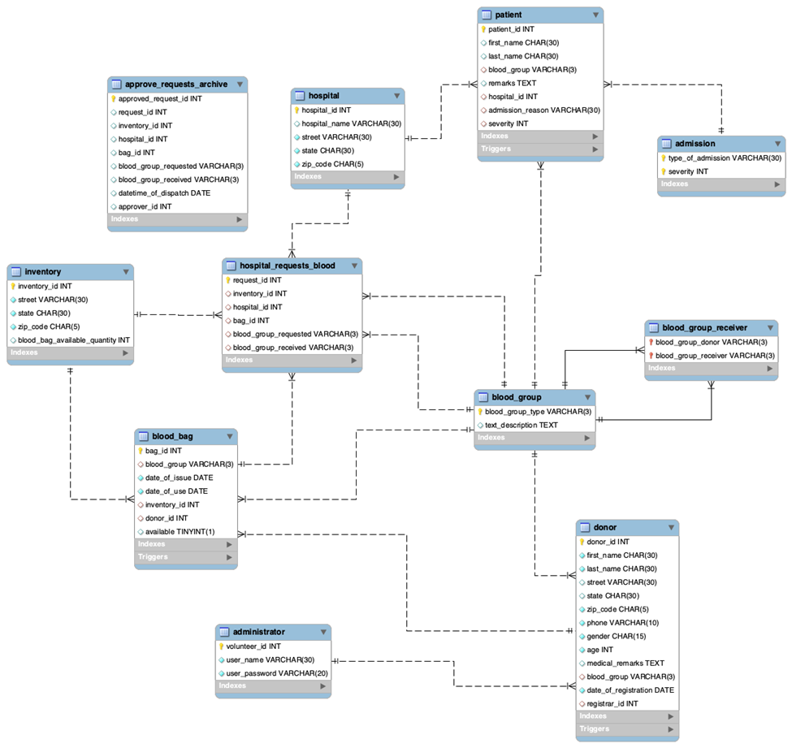

image-20231122194343977

**1) [25pt] SQL queries**

- For each table,

a) **[15pt]** Must present **screenshots of your SQL query** that creates a table for each table

* First, you need to define and present your own decision for enforcing the minimum cardinality for each relationship
* You must define and implement at least three data constraints.
* Your queries must consider all required data constraints and table constraints that are defined in the design.

b) **[10pt]** Must present **screenshots of your SQL query** that inserts data entries for each table

(Weak/Strong) Max: Min - Min: Max

**2) [25pt] Result of Implementation**

Please submit an **exported database**.

* The minimum number of rows is **10**.

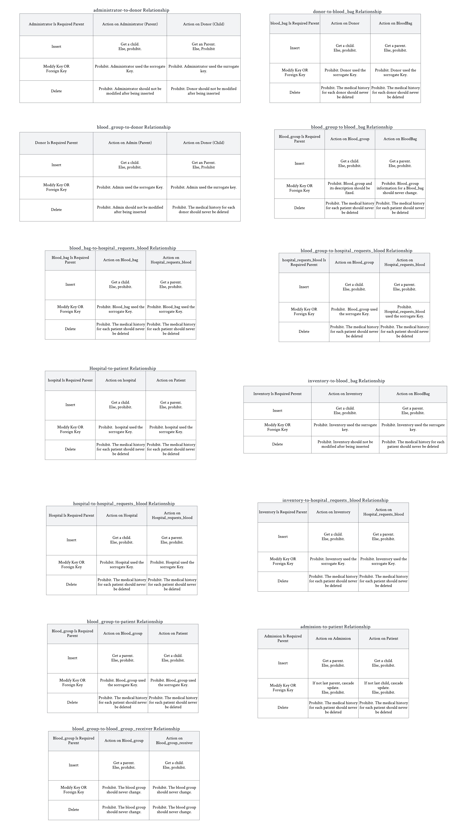

Table creating part:

-- SHOW ENGINE INNODB STATUS;
  
CREATE TABLE administrator (
  
 VolunteerID Int NOT NULL AUTO_INCREMENT,
  
 UserName VARCHAR(30) NOT NULL,
  
 UserPassword VARCHAR(20) NOT NULL,
  
 CONSTRAINT PK_ADMN PRIMARY KEY(VolunteerID),
  
 CONSTRAINT AK_ADMN UNIQUE(UserName)
  
 )ENGINE=InnoDB AUTO_INCREMENT = 1;
  
  
CREATE TABLE blood_group (
  
 BloodGroupType VARCHAR(3) NOT NULL,
  
 TextDescription TEXT DEFAULT NULL,
  
 CONSTRAINT PK_BG PRIMARY KEY(BloodGroupType),
  
 CONSTRAINT BG_Domain CHECK (BloodGroupType IN ('A+', 'A-', 'B+', 'B-', 'O+', 'O-', 'AB+', 'AB-') )
  
 );
  
  
CREATE TABLE blood_group_receiver (
  
 BloodGroupDonor VARCHAR(3) NOT NULL,
  
 BloodGroupReceiver VARCHAR(3) NOT NULL,
  
 CONSTRAINT PK_BGR PRIMARY KEY (BloodGroupDonor, BloodGroupReceiver),
  
 CONSTRAINT BG_FK1 FOREIGN KEY (BloodGroupDonor) REFERENCES blood_group(BloodGroupType)
  
 ON UPDATE NO ACTION
  
 ON DELETE NO ACTION,
  
 CONSTRAINT BG_FK2 FOREIGN KEY (BloodGroupReceiver) REFERENCES blood_group(BloodGroupType)
  
 ON UPDATE NO ACTION
  
 ON DELETE NO ACTION
  
 );
  
  
CREATE TABLE donor ( -- add trigger
  
 DonorID INT NOT NULL AUTO_INCREMENT,
  
 FirstName CHAR(30) NOT NULL,
  
 LastName CHAR(30) NOT NULL,
  
 Street VARCHAR(30) DEFAULT NULL,
  
 State CHAR(30) DEFAULT NULL,
  
 ZipCode CHAR(5) NOT NULL,
  
 Phone VARCHAR(10) NOT NULL,
  
 Gender CHAR(15) NOT NULL,
  
 Age Int NOT NULL,
  
 MedicalRemarks TEXT DEFAULT NULL,
  
 BLoodGroup VARCHAR(3) NOT NULL,
  
 DateOfRegistration DATE NOT NULL,
  
 RegistrarID Int NOT NULL,
  
 CONSTRAINT PK_DNR PRIMARY KEY (DonorID),
  
 CONSTRAINT AK_DNR UNIQUE(Phone),
  
 CONSTRAINT Valid_Age CHECK (Age > 0 AND Age < 100),
  
 CONSTRAINT Valid_ZipCode CHECK (
  
 ZipCode LIKE '[0-9][0-9][0-9][0-9][0-9]'),
  
 CONSTRAINT Valid_Phone CHECK (
  
 Phone LIKE '[0-9][0-9][0-9][0-9][0-9][0-9][0-9][0-9][0-9][0-9]'),
  
 CONSTRAINT BG_FK FOREIGN KEY (BLoodGroup) REFERENCES blood_group(BloodGroupType)
  
 ON UPDATE NO ACTION
  
 ON DELETE NO ACTION,
  
 CONSTRAINT ADMN_FK FOREIGN KEY (RegistrarID) REFERENCES administrator(VolunteerID)
  
 ON UPDATE NO ACTION
  
 ON DELETE NO ACTION
  
)ENGINE=InnoDB AUTO_INCREMENT = 11;
  
  
CREATE TABLE inventory (
  
 InventoryID INT NOT NULL AUTO_INCREMENT,
  
 Street VARCHAR(30) NOT NULL,
  
 State CHAR(30) NOT NULL,
  
 ZipCode CHAR(5) NOT NULL,
  
 BloodBagQtn Int NULL,
  
 CONSTRAINT PK_INVNTRY PRIMARY KEY(InventoryID),
  
 CONSTRAINT Valid_ZipCode CHECK (ZipCode LIKE '[0-9][0-9][0-9][0-9][0-9]'),
  
 CONSTRAINT Valid_BloodBagQtn CHECK (
  
 BloodBagQtn > -1)
  
)ENGINE=InnoDB AUTO_INCREMENT = 31;
  
  
CREATE TABLE blood_bag ( -- add trigger
  
 BagID INT NOT NULL AUTO_INCREMENT,
  
 BLoodGroup VARCHAR(3) NOT NULL,
  
 DateOfIssue DATE NOT NULL,
  
 DateOfuse DATE NOT NULL,
  
 InventoryID INT NOT NULL,
  
 DonorID INT NOT NULL,
  
 Available TINYINT(1) NOT NULL DEFAULT 1,
  
 CONSTRAINT PK_BB PRIMARY KEY(BagID),
  
 CONSTRAINT FK1_BB FOREIGN KEY (BLoodGroup) REFERENCES blood_group(BloodGroupType)
  
 ON UPDATE NO ACTION
  
 ON DELETE NO ACTION,
  
 CONSTRAINT FK2_BB FOREIGN KEY (InventoryID) REFERENCES inventory(InventoryID)
  
 ON UPDATE NO ACTION
  
 ON DELETE NO ACTION,
  
 CONSTRAINT FK3_BB FOREIGN KEY (DonorID) REFERENCES donor(DonorID)
  
 ON UPDATE NO ACTION
  
 ON DELETE NO ACTION,
  
 CONSTRAINT Date_Check CHECK (DateOfuse > DateOfIssue),
  
 CONSTRAINT Valid_AVL CHECK (Available = 1 OR Available = 0)
  
)ENGINE=InnoDB AUTO_INCREMENT = 51;
  
  
CREATE TABLE hospital (
  
 HospitalID INT NOT NULL AUTO_INCREMENT,
  
 HospitalName VARCHAR(30) NULL,
  
 Street VARCHAR(30) NOT NULL,
  
 State CHAR(30) NOT NULL,
  
 ZipCode CHAR(5) NOT NULL,
  
 CONSTRAINT PK_HSPTL PRIMARY KEY(HospitalID),
  
 CONSTRAINT AK_HSPTL UNIQUE(HospitalName),
  
 CONSTRAINT Valid_ZipCode CHECK (ZipCode LIKE '[0-9][0-9][0-9][0-9][0-9]')
  
)ENGINE=InnoDB AUTO_INCREMENT = 71;
  
  
CREATE TABLE hospital_requests_blood (
  
 RequestID INT NOT NULL AUTO_INCREMENT,
  
 InventoryID INT NOT NULL,
  
 HospitalID INT NOT NULL,
  
 BagID INT NOT NULL,
  
 BLoodGroupReq VARCHAR(3) NOT NULL,
  
 BLoodGroupRec VARCHAR(3) NOT NULL,
  
 CONSTRAINT PK_HRB PRIMARY KEY(RequestID),
  
 CONSTRAINT Req_BG_FK1 FOREIGN KEY (BLoodGroupReq) REFERENCES blood_group(BloodGroupType)
  
 ON UPDATE NO ACTION
  
 ON DELETE NO ACTION,
  
 CONSTRAINT Req_BG_FK2 FOREIGN KEY (BLoodGroupRec) REFERENCES blood_group(BloodGroupType)
  
 ON UPDATE NO ACTION
  
 ON DELETE NO ACTION,
  
 CONSTRAINT INVNTRY_FK1 FOREIGN KEY (InventoryID) REFERENCES inventory(InventoryID)
  
 ON UPDATE NO ACTION
  
 ON DELETE NO ACTION,
  
 CONSTRAINT HSPTL_FK1 FOREIGN KEY (HospitalID) REFERENCES hospital(HospitalID)
  
 ON UPDATE NO ACTION
  
 ON DELETE NO ACTION,
  
 CONSTRAINT BB_FK1 FOREIGN KEY (BagID) REFERENCES blood_bag(BagID)
  
 ON UPDATE NO ACTION
  
 ON DELETE NO ACTION
  
)ENGINE=InnoDB AUTO_INCREMENT = 121;
  
  
CREATE TABLE admission (
  
 TypeOfAdmission VARCHAR(30) NOT NULL,
  
 Serverity INT NOT NULL,
  
 CONSTRAINT PK_ADM PRIMARY KEY (TypeOfAdmission, Serverity),
  
 CONSTRAINT Valid_Serverity CHECK (Serverity >= 0 AND Serverity < 7) -- AIS
  
)ENGINE=InnoDB;
  
  
CREATE TABLE patient ( -- add trigger
  
 PatientID INT NOT NULL AUTO_INCREMENT,
  
 FirstName CHAR(30) NULL,
  
 LastName CHAR(30) NULL,
  
 BLoodGroup VARCHAR(3) NOT NULL,
  
 Remarks TEXT DEFAULT NULL,
  
 HospitalID Int NOT NULL,
  
 AdmissionReason VARCHAR(30) NOT NULL,
  
 Serverity Int NOT NULL,
  
 CONSTRAINT PK_PTNT PRIMARY KEY(PatientID),
  
 CONSTRAINT Ptnt_BG_FK1 FOREIGN KEY (BLoodGroup) REFERENCES blood_group(BloodGroupType)
  
 ON UPDATE NO ACTION
  
 ON DELETE NO ACTION,
  
 CONSTRAINT ADM_FK1 FOREIGN KEY (AdmissionReason) REFERENCES admission(TypeOfAdmission)
  
 ON UPDATE CASCADE
  
 ON DELETE CASCADE,
  
 CONSTRAINT Ptnt_HSPTL_FK1 FOREIGN KEY (HospitalID) REFERENCES hospital(HospitalID)
  
 ON UPDATE NO ACTION
  
 ON DELETE NO ACTION,
  
 CONSTRAINT ADM_FK2 FOREIGN KEY (Serverity) REFERENCES admission(Serverity)
  
 ON UPDATE CASCADE
  
 ON DELETE CASCADE
  
)ENGINE=InnoDB AUTO_INCREMENT = 91;
  
  
CREATE TABLE approve_requests_archive (
  
 ApprovedRequestID INT NOT NULL AUTO_INCREMENT,
  
 RequestID INT NULL,
  
 InventoryID INT NULL,
  
 HospitalID INT NULL,
  
 BagID INT NULL,
  
 BLoodGroupReq VARCHAR(3) NULL,
  
 BLoodGroupRec VARCHAR(3) NULL,
  
 DatetimeOfDispatch Date NULL,
  
 ApproverID INT NULL,
  
 CONSTRAINT PK_ARA PRIMARY KEY(ApprovedRequestID)
  
)ENGINE=InnoDB AUTO_INCREMENT = 151;

Trigger Creating part:

TODO:

* finish the trigger

DELIMITER //  
CREATE TRIGGER donor_initail_value  
BEFORE INSERT ON donor  
FOR EACH ROW  
-- I am thinking if a donor come with the bloodtype not in the bloodgroup shall I also create a new entry in bloodgroup, or I shall think all possible bloodgroups already stores in the bloodgroup table?  
BEGIN  
 DECLARE VarVolunteerID INT;  
 DECLARE Flag1 INT DEFAULT 0;  
 DECLARE Flag2 INT DEFAULT 0;  
 DECLARE VarBloodGroupType VARCHAR(3);  
 SET VarVolunteerID = NEW.VolunteerID;  
 SET VarBloodGroupType = NEW.BloodGroupType;  
   
 SELECT COUNT(VolunteerID) INTO FLag1  
 FROM administrator  
 WHERE VolunteerID = VarVolunteerID  
   
 SELECT COUNT(VarBloodGroupType) INTO FLag2  
 FROM blood_group  
 WHERE BloodGroupType = VarVolunteerID  
   
 IF (FLag1 = 0 OR FLAG2 = 0) THEN  
 SIGNAL SQLSTATE '45000' SET MESSAGE_TEXT = 'Admin or blood group invalid';   
 END IF;  
   
  
END  
  
  
//  
DELIMITER ;  
  
DELIMITER ;  
  
DELIMITER //  
CREATE TRIGGER blood_bag_initail_value  
BEFORE INSERT ON blood_bag  
FOR EACH ROW  
  
BEGIN  
 DECLARE VarDonorID INT;  
 DECLARE VarBloodGroupType VARCHAR(3),  
 DECLARE VarInventoryID INT;  
 DECLARE Flag INT;  
   
 SET VarDonorID = NEW.DonorID;  
 SET VarInventoryID = NEW.InventoryID;  
 SET VarBloodGroupType = NEW.BloodGroupType;  
   
   
 SELECT SUM(COUNT(DonorID), COUNT(BloodGroupType), COUNT(InventoryID)) INTO Flag  
 FROM donor, blood_group, inventory  
 WHERE DonorID = VarDonorID AND VarBloodGroupType = BloodGroupType AND VarInventoryID = InventoryID;  
   
 IF (FLag < 3) THEN  
 SIGNAL SQLSTATE '45000' SET MESSAGE_TEXT = 'donor or blood group or inventory invalid';   
 END IF;  
  
END  
  
  
//  
DELIMITER ;  
  
DELIMITER //  
CREATE TRIGGER patient_initail_value  
BEFORE INSERT ON patient  
FOR EACH ROW  
  
BEGIN   
 DECLARE VarHospitalID INT;  
 DECLARE VarBloodGroupType VARCHAR(3),  
 DECLARE VarSeverity INT;  
 DECLARE VarReason VARCHAR(30);  
 DECLARE Flag INT;  
   
 SET VarHospitalID = NEW.HospitalID;  
 SET VarReason = NEW.TypeOfAdmission;  
 SET VarSeverity = NEW.Severity;  
 SET VarBloodGroupType = NEW.BloodGroupType;  
   
   
 SELECT SUM(COUNT(HospitalID), COUNT(BloodGroupType), COUNT(TypeOfAdmission), COUNT(Severity)) INTO Flag  
 FROM hospital, blood_group, admission  
 WHERE HospitalID = VarHospitalID AND VarBloodGroupType = BloodGroupType AND TypeOfAdmission = VarReason, Severity = VarSeverity;  
   
 IF (FLag < 4) THEN  
 SIGNAL SQLSTATE '45000' SET MESSAGE_TEXT = 'donor or blood group or inventory invalid';   
 END IF;  
  
END  
  
  
//  
DELIMITER ;